HOLYLAND ISLAMIC CULTURE CENTRE (HICC)
Charity No: SC054079
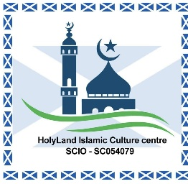
2/3 31 A Highholm Street, Port Glasgow PA14 5HN, United Kingdom

GIFT AID DECLARATION FORM
Boost your donation by 25p of Gift Aid for every £1 you donate
Gift Aid is reclaimed by the charity from the tax you pay for the current tax year. Your address is needed to identify you as a current UK taxpayer.

Donor Details
Full Name: _______________________________________________
Home Address: ____________________________________________
____________________________________________
Postcode: ____________________ Telephone: ________________
Email: _____________________________________________________

Declaration
☐ I want to Gift Aid my donation of £________ and any donations I make in the future or have made in the past 4 years to: HolyLand Islamic Culture Centre (HICC)
I am a UK taxpayer and understand that if I pay less Income Tax and/or Capital Gains Tax than the amount of Gift Aid claimed on all my donations in that tax year, it is my responsibility to pay any difference.

Signature: _______________________________ Date: ___________________

Please notify the charity if you:
• Want to cancel this declaration
• Change your name or home address
• No longer pay sufficient tax on your income and/or capital gains
If you pay Income Tax at the higher or additional rate and want to receive the additional tax relief due to you, you must include all your Gift Aid donations on your Self-Assessment tax return or ask HMRC to adjust your tax code.

